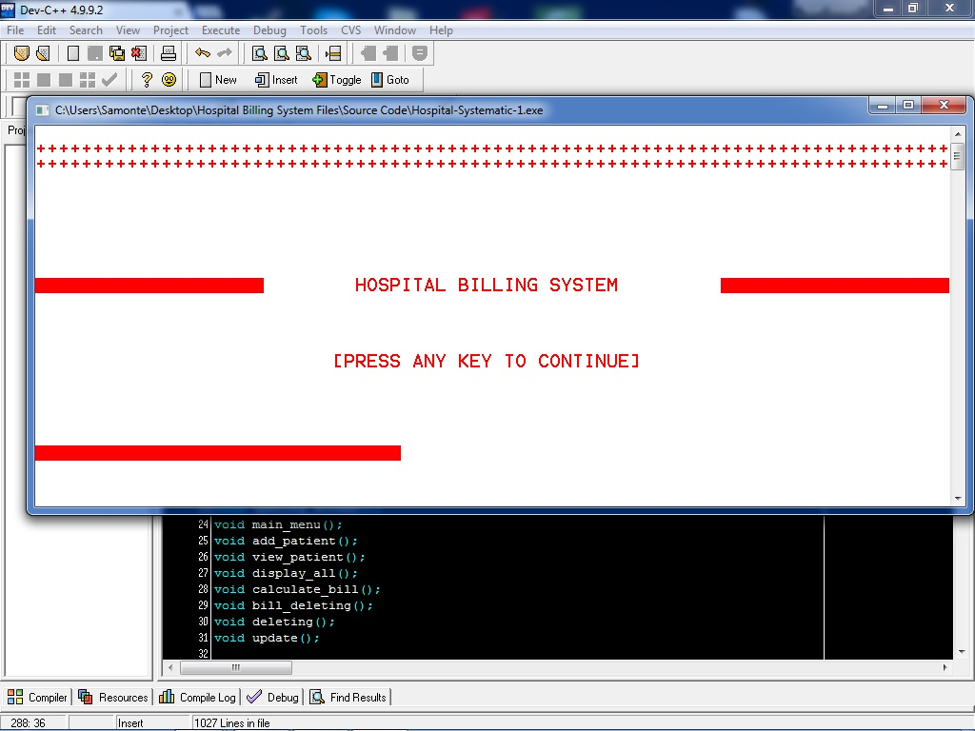**Overview of Program Design**

Figure 1

Figure 1- The opening screen

A white-red color of opening screen, which was in line to the most common color of hospital logos, picture and other graphical representations. By just clicking any key, you would see the progress bar, then the main menu or screen will flash on the screen.

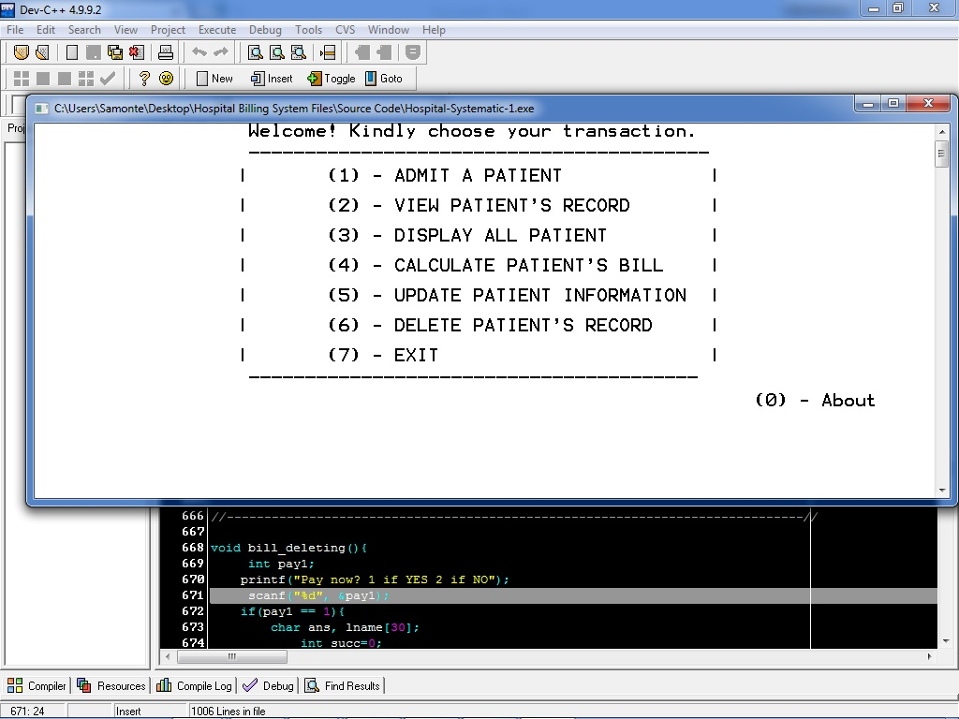

Figure 2

Figure 1- The main menu or screen

A white-black color of main menu or screen, simple and user-friendly interface for any kind of users. There were 8 choices consists of admitting a patient, viewing patient’s record, displaying all patient’s record, calculating the bill and discharging a patient, updating information, deleting patient’s record, termination of the system and the about. This main menu was a type and go, kind of method, no more pressing of the ENTER button, just the number of your choice and then you go.

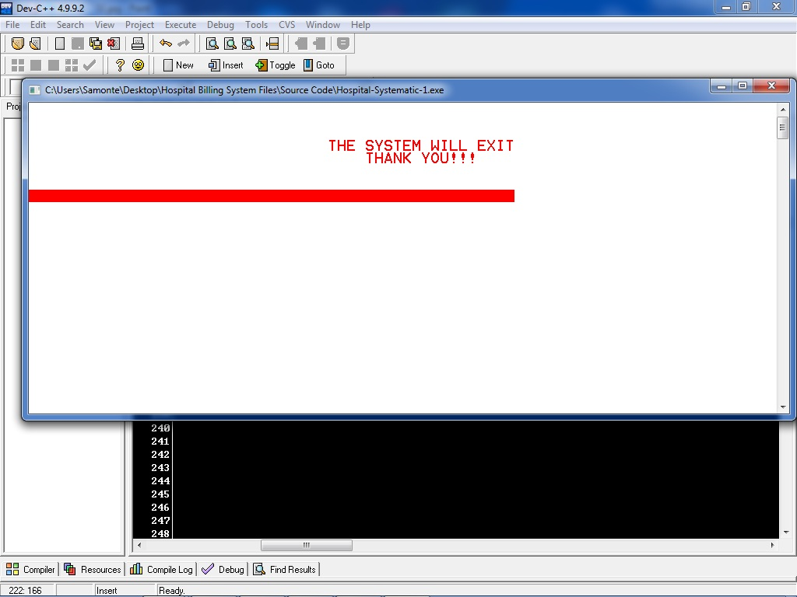

Figure 3

Figure 3- The termination screen

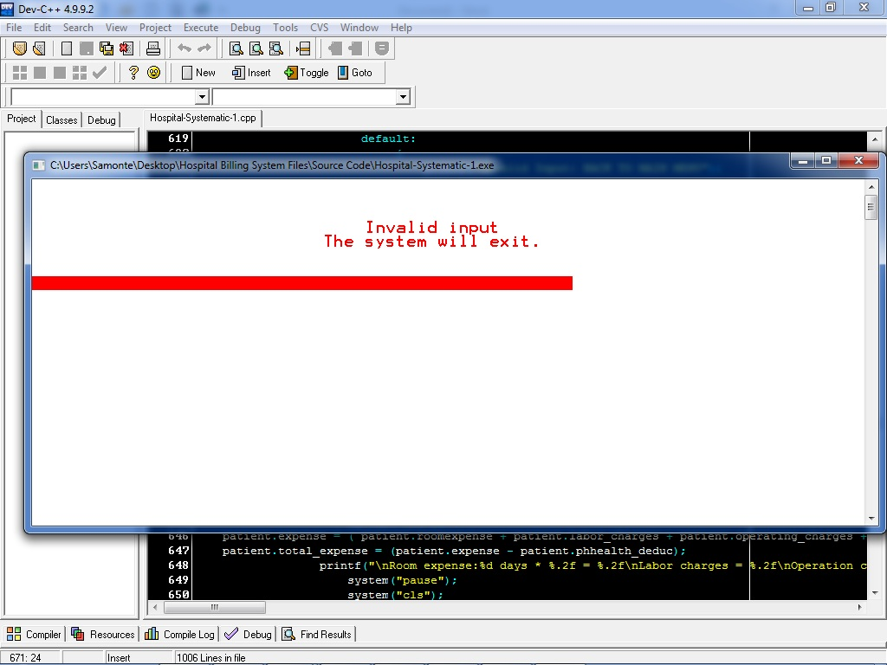Just like the opening screen, the termination screen was also in line into the most common color of hospital logos and the likes. It had also a progress bar that shows the process of termination.

Figure 4

Figure 4- The termination screen (when the user inputs an invalid choice.)

Figure 5

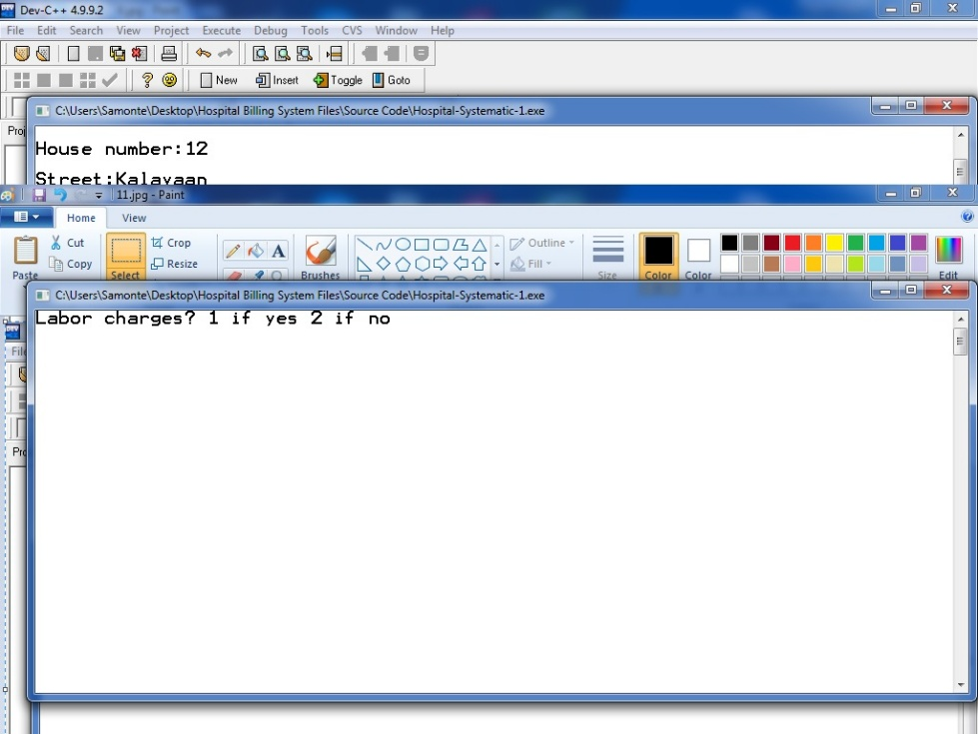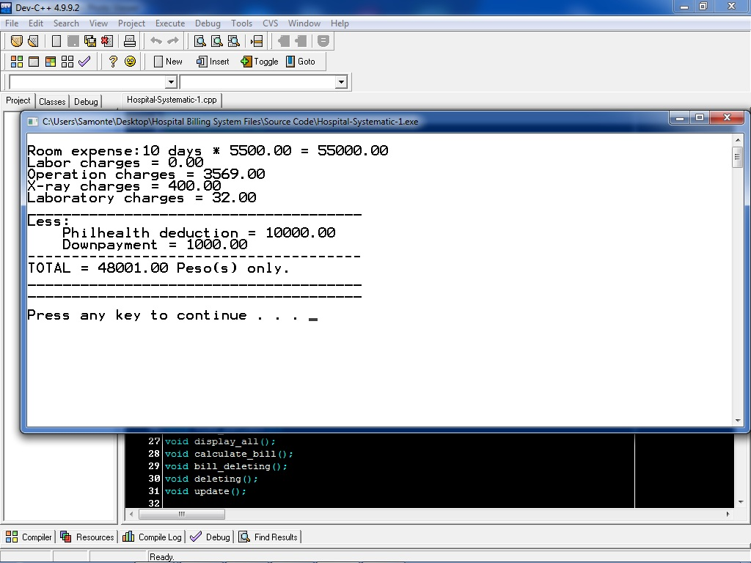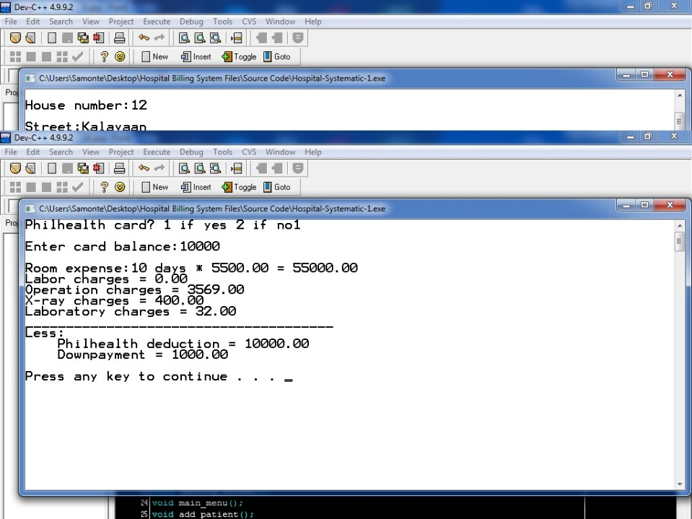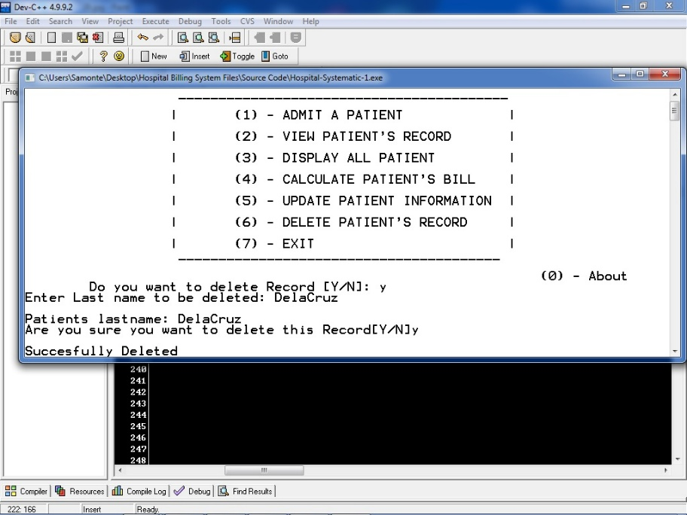

Figure 5- Windows and screen on the system

System’s User Interface Significant Characteristics:

1. Black and White theme of the system

* A theme that was simple yet helpful to any kind of users, a soft-looking type of screens or windows that can help user to choose proper and accurate.

1. Large font size

* The large font size helps users that had a sight difficulty, it can helps them to see it clearly and sharply.

1. Non-terminating system

* This system is a continuing process type of a system, it wouldn’t terminate until the user will choose the EXIT choice on the main menu. It can help the user to have a transaction after every transaction.